QUALITY ASSURANCE COUNCIL OF THE UGC
PROGRAMME REVIEWS

FORMAT OF DRAFT/FINAL REPORT
To be submitted by Review Chair to dqac@ugc.ac.lk as Word document, within 6 weeks of completing site visit.
Draft report will be emailed by DQAC to Dean / Rector, for corrections / comments (together with Excel file in Preliminary Report), to be sent back within 3 weeks.

Organization of report
Report should be structured into 8 Sections + Annexures, as described in Programme Review Manual (p 98–102)
Section 1: Introduction to programme
Section 2: Observations on SER
Section 3: Description of review process
Section 4: Faculty’s approach to quality and standards
Section 5: Judgment on each of the 8 criteria
Section 6: Grading of overall performance
Section 7: Commendations and recommendations
Section 8: Summary
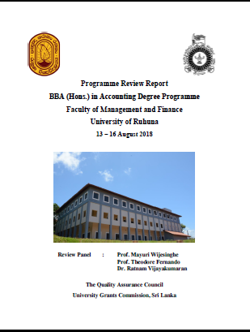
Annexures

Format of cover page
- University logo on left
- UGC logo on right
- Details of the PR on top with the year and dates of review
- Photograph of University / Faculty / Dept
- Names of reviewers below photo
- Name-UGC and QAC bottom of page
Scanned copy of page with signatures to be inserted after cover page, with following details
University:
Faculty:
Program:
Review Panel:
Name | Signature
Date:

Additional guidance
- List of Contents should include relevant pages of each Section and Criterion (1-8)
- Each main Section (1-8) to be started on a new page, with heading centre aligned and subheadings left aligned
- Annexures must include:
  - final schedule for site visit
  - all attendance sheets from meetings
- Optional annexure: additional photographs taken during site visit (reduce file size)
- Font and size
Calibri font 14 (bold) for main Section headings
Calibri font 13 (bold) for sub-headings
Calibri font 12 for text in paragraphs
- Text colour: black
- Line Spacing
Main Section headings and text – 3.0
Subheadings and content – 2.0
Paragraphs – 1.5
Sentences in paragraphs – 1.15
- Numbering of tables and figures: use number of the section followed by sequential number within the section: e.g.1.1, 2.3
- Capitalization in text: use only for abbreviations and as recommended for names of people, departments, universities, etc.
- Word count:
  - Single Programme (3 or 4 years’ duration): maximum 8000 words
  - Cluster Review / 5 year program: maximum 12,000 words

Final Report needs to be submitted in soft copy (Word and pdf) and a single hard copy

